CS 340 README

About the Project/Project Title
This project allows users to access a database for animals and gives them the ability to create new animals, update existing animals, view existing animals, and delete if needed. A dashboard was created to display this info in a way that makes sense.

Motivation
This project exists to develop an interactivr dashboard for Grazioso Salvare to allow their employees to better serve the animals at the shelter

Getting Started
To start this program a user would enter the Mongo shell and import the csv aac_shelter_outcome.csv. Next the user would need to crate an index to organize the data to be read. Then the user would want to create an admin and an aacuser account. Finally, the user would need to access or install a Python IDE to run the program.

Installation
Python and MongoDB will be needed to run the files and access the data base.

MongoDB was chosen to run this project because if it’s ease of interaction with Python using it’s driver PyMongo. MongoDB is flexible and easy to rescale. Dash contains useful features to build interactive dashboards that were needed for this project.

Usage
Use this space to show useful examples of how your project works and how it can be used. Be sure to include examples of your code, tests, and screenshots.

Code Example
The code allows a user to test, add, and edit animals in a shelter

Tests
The test first imports the data, then you can search by breed and the found_documents function will return all information in the database about said breed

Screenshots
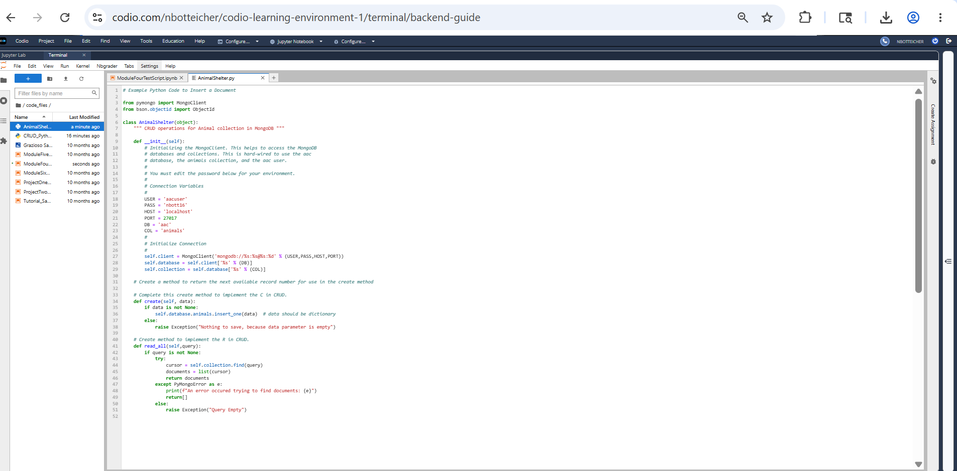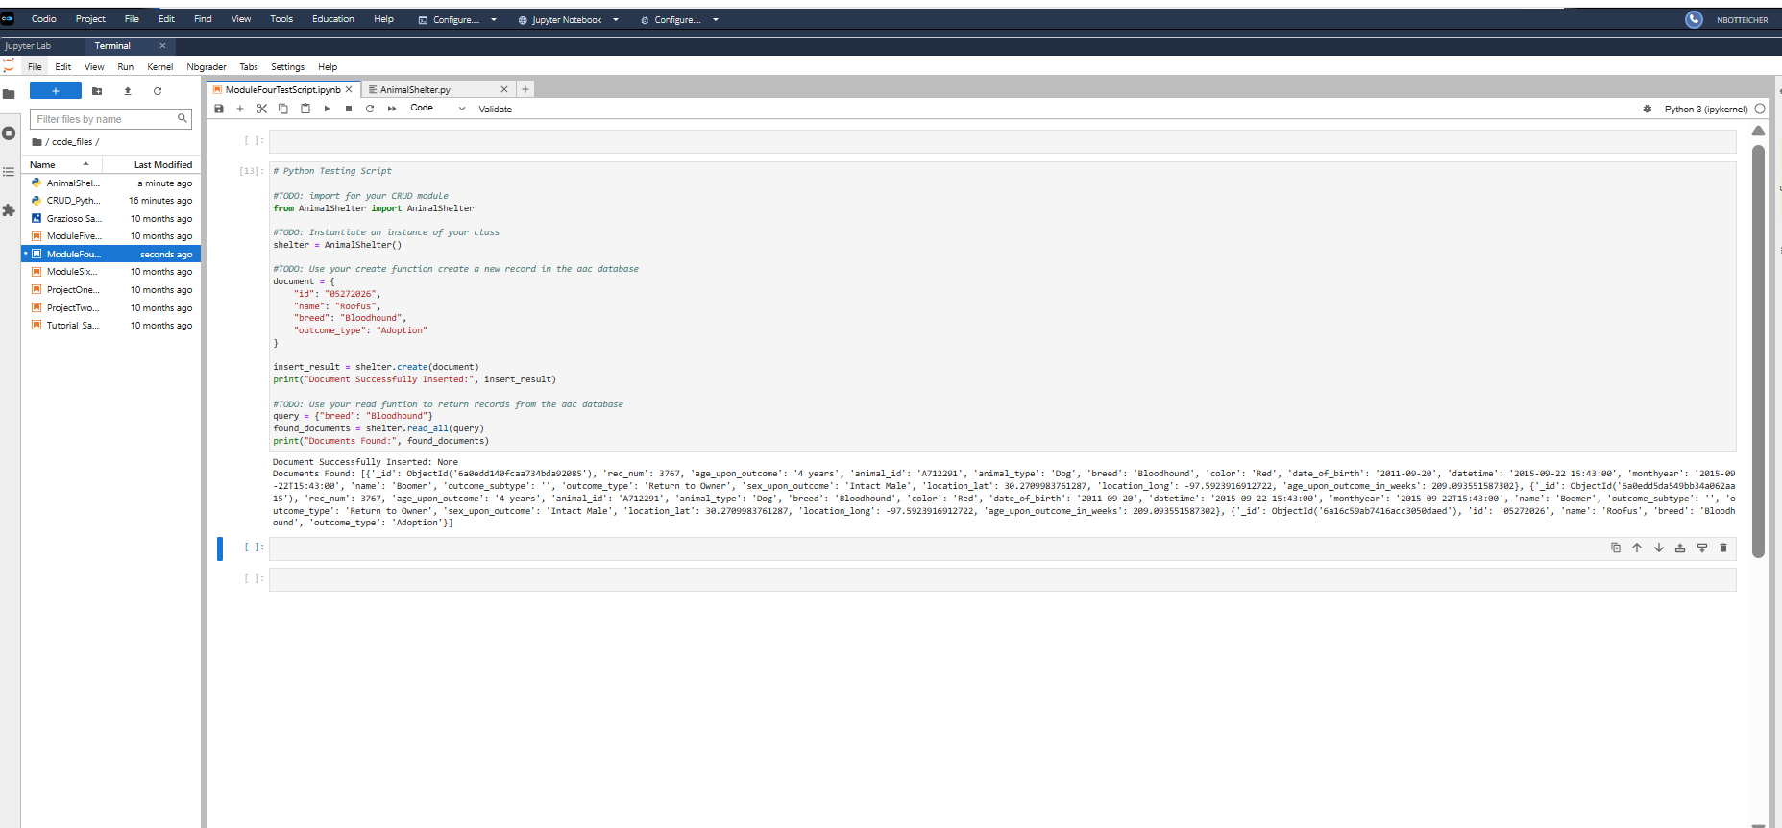

Challenges
The whole way through this project I dealt with issues that would not allow the dashboard to load how it needed to, and I never really figured it out.

Contact
Your name: Nick Botteicher

